Calvert Green - New NEAP

3

2

1

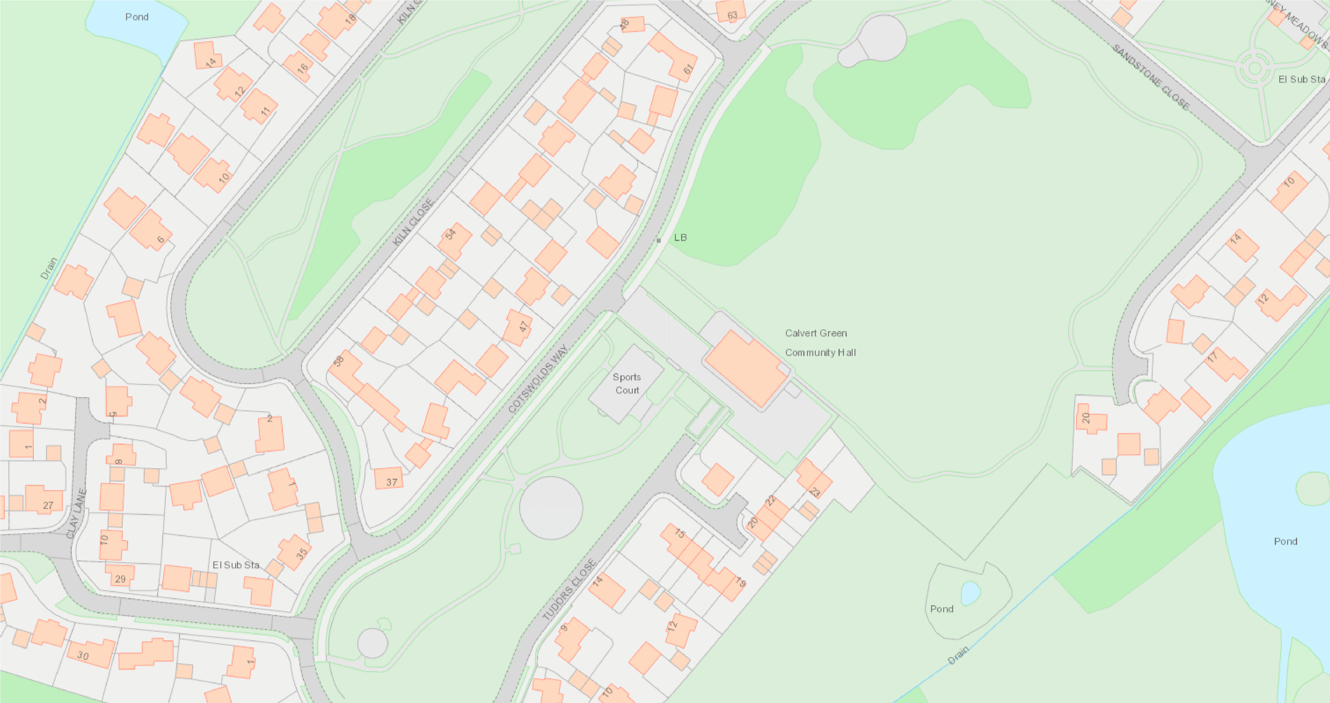

Toddler

Toddler/Junior

Junior/Teen

New Path